Computer Language Coding Concepts

Completely Explicit Display of Assignment
An assignment has a simple notation:

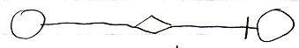

But it is an implicit notation. Assignment needs such a simple notation, because it is one of the most basic kinds of commands in computer technology. Other articles have demonstrated how assignment can be displayed in a more explicit way. The current article goes as far as to display assignment completely implicitly.

The point of this article is to demonstrate how assignment works at system-level and also to demonstrate how impractical the explicit notation is.

The main thing explicitly displayed here is that the system interface is opened up, showing explicitly what aspects and system commands are called. The following picture demonstrates this:

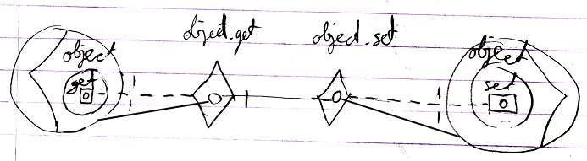

The picture that follows goes even further. It also displays access connectors:

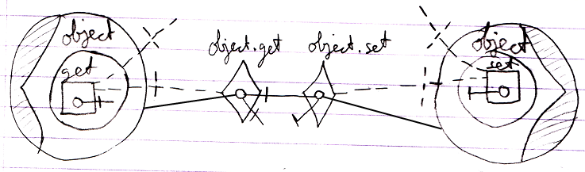

Perhaps you could go even further in discovering more things to explicitly display, but the main point is: you have now seen how system operations work internally and you can also see that it is highly unpractical to express all the assignments explicitly like that.

You could also explicitly display the assignment call, which basically puts the whole thing inside a command:

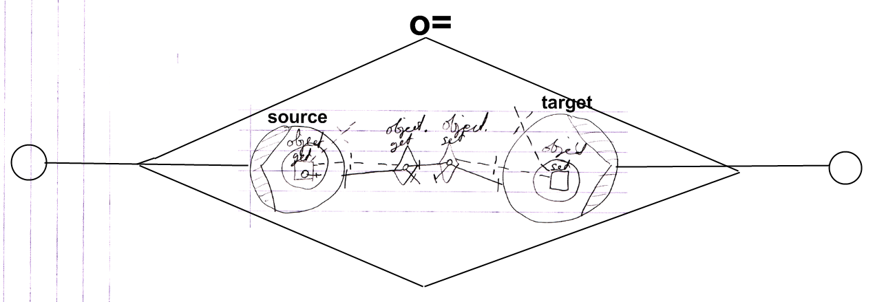

But ofcourse a more practical notation is:

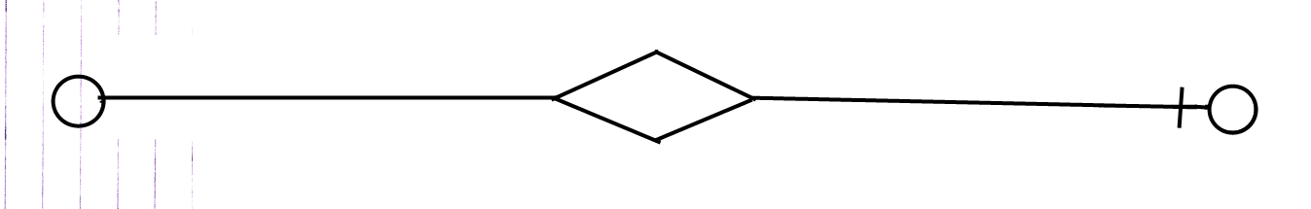

See also: System Objects

Author & Copyright: Jan-Joost van Zon Date: August 11, 2009 – August 11, 2009 Location: Oosterhout, The Netherlands Status: Finished

